# Postprocessing Instructions

## Opening the CTAK User Interface (UI)

* If CTAK is not open do the following
  + Start the main routine (if you need help with this, please read the section labelled, ‘Start the main routine’.
  + Press the ‘Launch CTAK’ button
  + 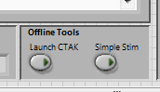
  + CTAK will open shortly, and you will now have access to the postprocessing tools

## Loading 3D Stack

* Go to postprocessing tools
* Click on Load Full3D 🡪 Go

## Fast Scan Analysis (with 3D Neuron)

* In the CTAK UI (formerly DDRAW UI), on the postprocessing tools select the **Fast Scan Analysis** from the pull down menu ‘**PP Selection**’, and press GO
* Press ‘Load ELF’ (experimental log file) and locate your folder where your datafiles from your experiment are stored
* Double click on the ‘EXPLOGFILE_[DATE]_[TIME].txt’
* If you want all of the files processed select **Process All** (will take more time), otherwise select **Choose One Scan**.
  + **NOTE**: currently the ‘Process All’ is deactivated’ needs to be reimplimented, use **Choose One Scan** for now.
* In ‘**Msmt Index Entry**’ select the **rapid scan** that you want to process
* Press **CONTINUE**
* If you have the postprocessing files select **Use Existing** otherwise select **Generate**
  + If you have existing postprocessing files …
* Otherwise, if you selected **Generate**
* When the ‘Select the type of Fast Scan’ box opens up, either select **Volume Fast Scan (T)**, or select **Planar Fast Scan** (F) 🡪 it might take at least a few minutes before this box opens up to process the files.
* Once the analysis completes, you can access the postprocessing files.
  + **Accessing the image stack**: Once the computations conclude you can access the image stack. If the Drawing Functions Active LED indicator is not lit, manually press it to activate the front panel controls on the CTAK UI (located in the bottom left corner in the CTAK UI – needs to be bright green)

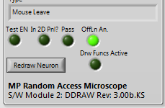

* + You can now scroll through the stack of images using the mouse wheel (NOTE: make sure the window is activiated by clicking on the window frame)
  + **Accessing the 3D Neuron skeleton** (the interpolated POIs that were created from the user drawn neuron): In the top right window of the CTAK UI, the 3D neuron is displayed. There are several ‘**Node Display Modes**’ that can be viewed. They are as follows:
  + **3D Neuron Modes**
    - *Node Types*: distinguishes soma (blue), branching points (red), tips (green), shaft points (yellow)
    - *Path IDs*: the colors of the neuron POIs correspond to the colors of the traces on the Delta F/F0 Intensity vs. time plot. The longest path is white, and is ordered from longest to shorted and from red to violet in color code.
    - *Tagged for Analysis*: The user has the option of selecting only certain POIs for display in figures and for analysis. If the user has selected particular POIs for analysis, the POI(s) selected will be red. POIs not selected for analysis will be grey. This is particularly useful in the **Intensity vs. Time Plot Analysis Tool**.

## Intensity versus Time Line Plot Analysis Tool

**IMPORTANT: All parameters should be changed, followed by the ‘Refresh’ button. If you don’t press the Refresh button, no parameters will be changed in the line plot. The line plot should be closed when not needed.**

**IMPORTANT: Please press ‘quit’ to exit the line plot and return to the CTAK UI options.**

1. Use this tool to analyze Intensity vs. time of all or a subset of POIs from the interpolated neuron. This can only be executed after the Fast Scan Analysis has taken place using pre-existing data (see Fast Scan Analysis). Once the Fast Scan Analysis has been performed and has concluded, ensure the ‘Drawing Functions Active’ LED is lit.
2. In the 2D Image Viewer your interpolated neuron will be visible (i.e. POIs on the dendritic arbor). Using the POI Selection Keys, select the POIs desired for analysis (see CTAK UI Actions). NOTE: Data must have been collected during experimentation on the POI for analysis. If you select Path IDs in the Node Display Mode, all POIs that have data associated with the POI, collected DURING the experiment, will have an associated color other than grey.
3. Add the desired POIs to the ‘**Active Analysis List’** (see CTAK UI Actions). If you want all POIs for analysis skip to the next instruction. NOTE: Nodes are analyzed in the order that they are selected in. NOTE: If you selected ‘Tagged for Analysis’ in Node Display Mode, you will see the corresponding nodes highlighted in red in the 3D Neuron Display.
4. Once the POIs have been selected, or in the case where none have been selected (entire neuron) in POSTPROCESSING TOOL, select the Multiline Node Plot from **Select Analysis** and then press GO
5. Here are suggested settings for Delta F / F0. These are only recommended values. If you want more information on the calculations read “Calculation of Calcium Signals” (Jia, Rochefort, Chen and Konnerth, 2011).

|  |  |
| --- | --- |
|  |  |
| Planar Rapid Scan (120 Hz) | Volume Rapid Scan (4-10 Hz) |

1. Entered your values to calculate DF/F0
2. There are several parameters that will change the appearance of the line plot.
   * Raw (f), dF/F0 (t) – choose between the raw signal and DF/F0.
   * Grey (f), Clr (t) – choose between a colored plot and a grey plot
   * User Node Filter
     1. All nodes (F), Tag’d or Usr Drawn Nodes (T) – choose between all POIs (where data has been collected in the experiment for each POI, or choose between the POIs that were added to the Active Analysis List.
     2. User Drawn Nodes (F), Tag’d NodeIDs (T) – if you only want to see data that corresponds to POIs that were originally drawn before the neuron was interpolated ensure this parameter is set to false (i.e. LED off)
     3. Reverse NodeIDs Order – this simply reverses the order of the Active Analysis List such that the plot order of POIs is reversed
   * LPF (low pass filter) – if you want to filter the data using a low pass filter, set the following:
     1. f_samp - The POI rate Hz
     2. f_cutoff – This is the cutoff frequency for the low pass filter. Must be less than ½ of the sampling rate to satisfy Nyquist sampling theorem.
   * Max Color Lvls
     1. If you want to change the number of colors on your color line plot (i.e. each line plot is a different color). Change this a different number.
   * Vertical Offset – change this value to shift the numerical distance between POI traces (for aesthetics only).
3. Here is an example of a VRS for several POIs that have been selected by the User

|  |  |
| --- | --- |
|  |  |
|  | |

1. Generate Images
   * Pressing this button will yield several analysis plots in the ‘pp_output’ directory.
     1. dF_F0 –This image will produce the standard DF/F0 image using only the POIs selected by the user, or all POIs if the user has selected the parameters for all POIs. NOTE: The user is responsible for identifying how the stimuli are arranged programmatically. A logic output will change when the stimuli changes producing a digital siganl by the Stimbox and received by the laser microscope system. The software development team encode these signals with the changing stimuli and are experiment dependant.

In the analysis, the user needs to ensure that the stimuli are grouped accordingly as shown in the Group_indices array. In the following example, 4 OFF flashes are grouped into group ‘0’. The transition point (from solid LED ON to solid LED OFF) , which is detected, is grouped into group ‘1’, and 4 ON flashes, with LED OFF, are grouped as group 2. The following entries into the Group_indicies represent the grouped stimuli plus the transition.



* + 1. avg_perStimset – this image will average the responses of each type of stimuli (e.g. ON, OFF, transition) based on the POIs in the Active Analysis List, and how each type of stimuli is grouped in the Group_indices array. In the following example, the four OFF flashes, transition point, and ON flashes are shown as three groups. Note: **Window Size (samples)** is the number of samples to average per stimulus. ¼ of the samples in Window Size will occur before the start of the stimuli and ¾ of samples will occur after the start of the stimuli since the stimuli start time acts as a reference between all similar stimuli in the group.

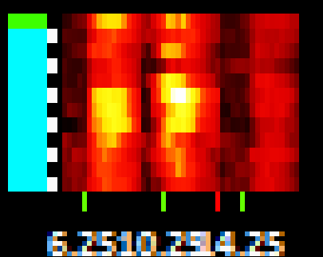

* + 1. Max dF/F0 – The value displayed for the maximum DF/F0 can be modified as desired. Lower this value to reduce the threshold in the image for maximum DF/F0.
    2. Pxl rows per array – this is simply the number of pixels each trace will occupy in your dF/F0 color plot, and is a duplicate of the orginal data. Increasing this value, will increase the verticle height of the figure. 3 is the recommended value.

1. Press ‘OK’ to view the I(t) vs. t line plot, and press OK to the open dialogue box
2. Change the Node Display Mode to path IDs to see the paths and see which of the POIs you want to observe as a line scan
3. Using the POI select keys select the 1st POI to add to the analysis list and then press ‘B’ (press CTRL-B to clear the list at anytime)

Seeing the conversion between

## Running the CUSUM TOOL

* When the CUSUM – Run Analysis.vi opens up, this VI will ask if you want to enter the CUSUM Test Mode. If you select the test mode, the CUSUM will enter a while loop and can be used to modify the parameters of the CUSUM and see the output for each parameter set entered. Another window, ‘Build Response Matrix will open up and will be modified for each parameter entry that is entered in the CUSUM – Run Analysis.vi. If you want to see the response for various POIs, make sure to hit the ‘Refresh’ button on the Build Response Matrix.vi. Each detected action potential will be marked according to the event. To quit, make sure to quit the Build Response Matrix first. Simply close the CUSUM – Binary Output.vi at anytime. Lastly, press Quit on the CUSUM – Run Analysis.vi to continue the major routine
* This vi will allow you to see the fastscan data lines. Needs to be tweaked though
* Open a Rapid Scan folder (see EXPLOGFILE_[DATE].txt for navigating folders), when requested
* Press the Offline Analy? (F) button
* NOTE: Values in Scan Msmt.lvlib:Rapid Scan.lvclass:Parameter Entry for Offline Analysis.vi are hardcoded
  + PMT voltages must be equal to those used in Hamamatsu-1.lvclass:Initialize.vi
    - Currently Max = 7.35 V, Min = -2.05 V

Process Node Intensity Data.vi, Create Px Column.vi

## Maximum Intensity Projection.vi

* Open the VI, and enter the folder where the PNG stack is
  + Filenames of the images must be in the format scanimage_[#].png
  + To increase the brightness of the image
    - Press offline button
    - Enter in a factor to shift the image intensity by a factor of N2

## View how the schedule is built

* Use Build Fast Scan Schedule 2.vi
  + Set Online Analysis = TRUE
* Enter the path of Locate the interp-neuron-.dat in ‘Filepath – Interpolated Neuron’ file created after the draw routine is run
* Enter the folder for the Z-Stg Trace from the next step (i.e. ..step[N]\fastscan\rawdata)
* Ensure the offline parameters are set to match the online parameters used during the routine
  + To do: create a log file to contain this information so this is not necessary and can be acquired automatically

## How to view the actors running, object msmts available, and results that are queued

Click on the ‘Observe Control Queues’ button on the DDRAW UI

* Will open up Controller.lvclass:Show Queue States.vi

## Loading a dataset and seeing the results of the last scan

Open MSMT UI

Click on open DDRAW for offline analysis

In the DDRA, click on **‘PP – Fast Scan General’**

## Loading a 3D stack image (image data only)

From the ‘PP Selection’ Pull down menu, select **Ld Img Stk (Imgs Only)**, and select the folder containing the Full3D, and select the ‘rawdata’ folder.

* [DEV NOTE/todo: This should be changed to find the raw data on its on]

## Loading a neuron, full3D stack and the user-drawn node structure (temp only)

1. Open MSMT UI, and Launch DDRA
2. In Postprocessing Tools pull down menu select ‘Rebuild User Neuron’ and press GO
3. Press ‘Load ELF’, and locate the ELF file in the experiment directory of your dataset
4. Double click on the ELF file
5. Press ‘Choose One Scan’ to process a single scan or “Process all” for entire experiment
6. Enter the Rapid Scan, or Rapid Scan Planar **index number** into the **Msmt Index Entry** after the Full3D that you want to analyze
7. Press CONTINUE
8. The stack and user drawn neuron will load into the DRAA UI
9. If you press INTERPOLATE, interpolate will occur with the current specifications set on the MSMT UI
10. NOTE: Currently, I haven’t developed a quick switch back the user-drawn neuron
11. NOTE: Currently, the nodes after loading this routine show grey, just change the Node Display Mode
    1. Node Type – distinguishes branches, tips, branching points etc
    2. Node Paths – shows longest paths to shortest paths on the rainbow color scale (white is longest path)
    3. Priority – this has been commented out – not active at this point, but can be easily reinstalled

## Loading a previously stored neuron stack and 3d structure and TEST Branch Image Mask

* Press the ‘Branch Mask’ button in Post Processing.
* Select the ELF file that was used to record the data
* Select the rapid scan time point after the DRAW-FULL you want to open, and select the Rapid Scan Index after the morphology (i.e. drawn neuron) you want to see

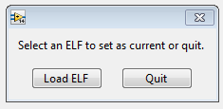

Click Load ELF (experimental logfile)

Select a similar file in the dataset that you just collected:



This dialogue box will open up. Select the fastscan measurement you want to analyze and press continue, followed by ‘OK’

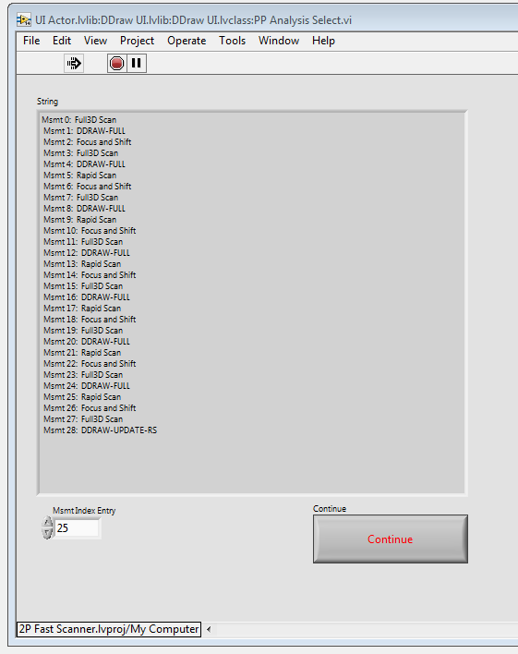

The ‘Observe Fastscan Data Signals.vi’ will open up and start showing the data.

Click on the 3D Image Viewer and Use the ‘Timeline Controls’ to observe the changes over the rapid scan